

Blood Bank Management System

CCP Project Report

Submitted By:
Group Members:
Muhammad Rehan [RCF-30177]

Submitted To:
Instructor:
Ms. Sehrish Ferdous

Date of Submission:
2nd June, 2025

Table of Contents
1. Introduction 4
1.1 Project Overview: 4
1.2 Problem Statement: 4
1.3 Objectives: 4
2. System Requirements 4
2.1 Functional Requirements: 5
2.2 Non-Functional Requirements: 5
3. Tools / Technology Used 5
4. Main Features of the System 5
5. Database Design 6
5.1 Entity-Relationship Diagram (ERD): 6
5.2 ERD/Enhanced ERD Screenshot’s: 7
5.3 Database Schema: 9
5.4 Relational Database Diagram Screenshots: 9
5.5 Normalization Process: 9
6. Implementation Overview: 10
7. Database Implementation 10
7.1 DBMS Selection: 10
7.2 Table Creation Scripts: 10
7.3 Constraints and Relationships: 11
8. Data Population 12
8.1 Sample Data Insert Statements: 12
8.2 Explanation: 13
9. SQL Query Implementation 13
9.1 CRUD Operations: 13
9.2 Complex Queries: 13
10. User Interface Development 14
10.1 Front-End Design Overview: 14
10.2 Screenshots: 14
10.3 UI Components: 18
11. System Testing and Validation 18
11.1 Testing Strategy: 18
11.2 Performance Testing: 19
12. Testing 19
13. Challenges Faced 19
14. Outcomes 19
15. Appendix 19
14.1 Java Swing GUI Code: 19

Blood Bank Management System

Introduction

1.1 Project Overview:
The Blood Bank Management System is a desktop-based Java Swing application connected to a MySQL database. It is designed to efficiently manage blood donors, recipients, inventory, and requests. The system allows administrators to register/login, manage blood transactions, and generate summaries and statistics, aiming to digitize and automate blood bank operations.

1.2 Problem Statement:
Before this system, blood banks used to keep records by hand or on simple computers, which caused problems. Donor details were lost, blood stock was hard to track, and sometimes expired or wrong blood was given to patients. Patients and hospitals had to wait longer to get the blood they needed. This system was needed to make blood management easy, fast, and safe.

1.3 Objectives:
- Enable secure admin login and registration.
- Provide CRUD functionality for donors, recipients, and blood inventory.
- Maintain records of blood requests and their status.
- Provide real-time dashboard statistics.
- Enhance usability with a modern, intuitive GUI.

System Requirements

2.1 Functional Requirements:
- Admin authentication (login and registration)
- Add, update, delete, and view donors
- Add, update, delete, and view recipients
- Add, update, delete, view blood inventory records
- Create and manage blood requests
- Dashboard displaying real-time counts

2.2 Non-Functional Requirements:
- Usability: Easy-to-navigate GUI using Java Swing
- Performance: Fast database operations using JDBC
- Security: Basic validation and secure admin access (suggested improvements: password hashing)
- Portability: Platform-independent through Java

Tools / Technology Used

Component | Technology Used
Programming Language | Java (JDK 21)
GUI Framework | Java Swing
Database | MySQL
Connection | JDBC
IDE | Eclipse

Main Features of the System
Login
- Only registered users (admin/staff) can access the system.
- Input validation and password protection implemented.
- Stores user credentials securely.

Register
- New users can sign up by providing name, email, password, and role.
- Ensures unique usernames and valid data entries.

Donor Management
- Add new donors with attributes: name, age, gender, blood group, contact.
- Update/delete donor information.
- View donors by blood group or name.

Recipient Management
- Add new recipients requesting blood.
- Maintain recipient details (name, age, blood group, contact, urgency).
- Track recipient request history.

Blood Inventory
- Automatically updates when a donor donates or when blood is issued.
- Displays quantity of each blood group available (A+, A-, B+, etc.).
- Alerts if stock is low for a blood group.

Blood Request Management
- Recipients can place blood requests.
- System checks availability in inventory.
- If available, request is processed and stock updated.
- If not available, an alert is shown.

Database Design

5.1 Entity-Relationship Diagram (ERD):

Entities:
- Staff (StaffID, Username, Password)
- Donor (DonorID, FullName, Age, Gender, BloodGroup, Contact)
- Recipient (RecipientID, FullName, Age, Gender, BloodGroup, Hospital)
- BloodInventory (BloodGroup, Quantity)
- BloodRequest (RequestID, RecipientID, BloodGroup, QuantityRequested, Status, RequestDate)

Relationships:
- One-to-many between Recipient and BloodRequest
- Many-to-one between Recipient and BloodGroup
- One-to-many between BloodGroup and Donor
- One-to-one between BloodGroup and BloodInventory
- Many-to-one between Donor and Staff
- One-to-many between BloodGroup and BloodRequest

5.2 ERD/Enhanced ERD Screenshot’s:
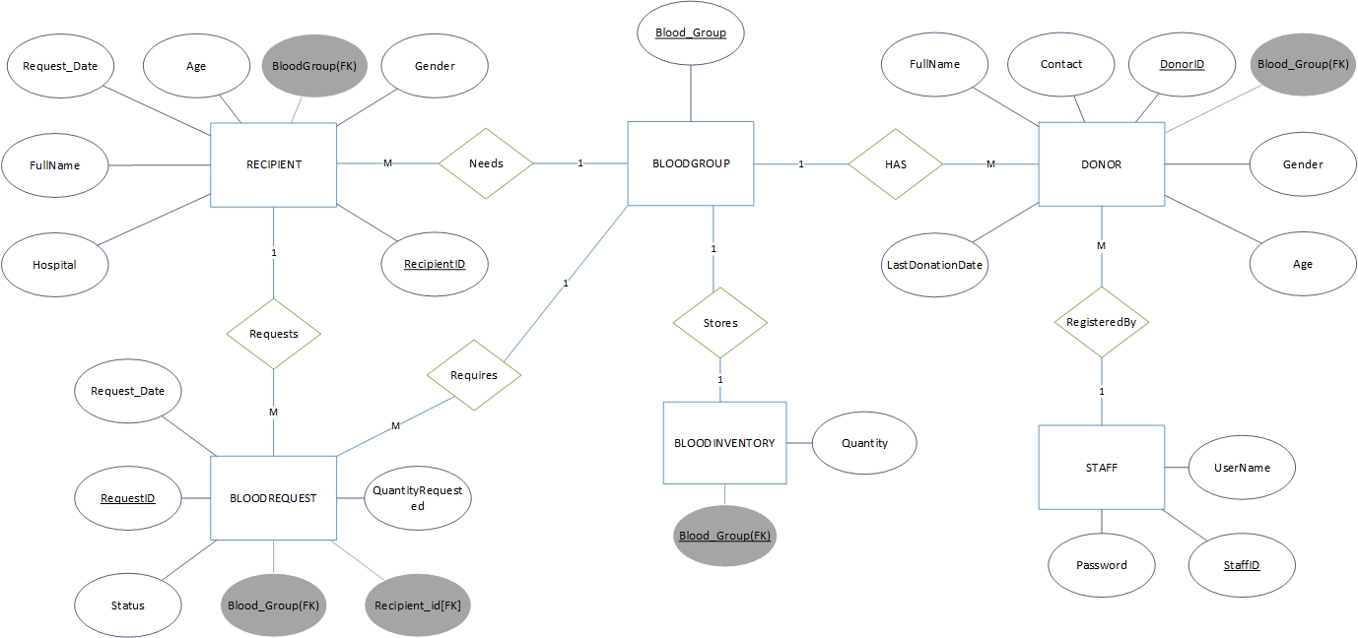
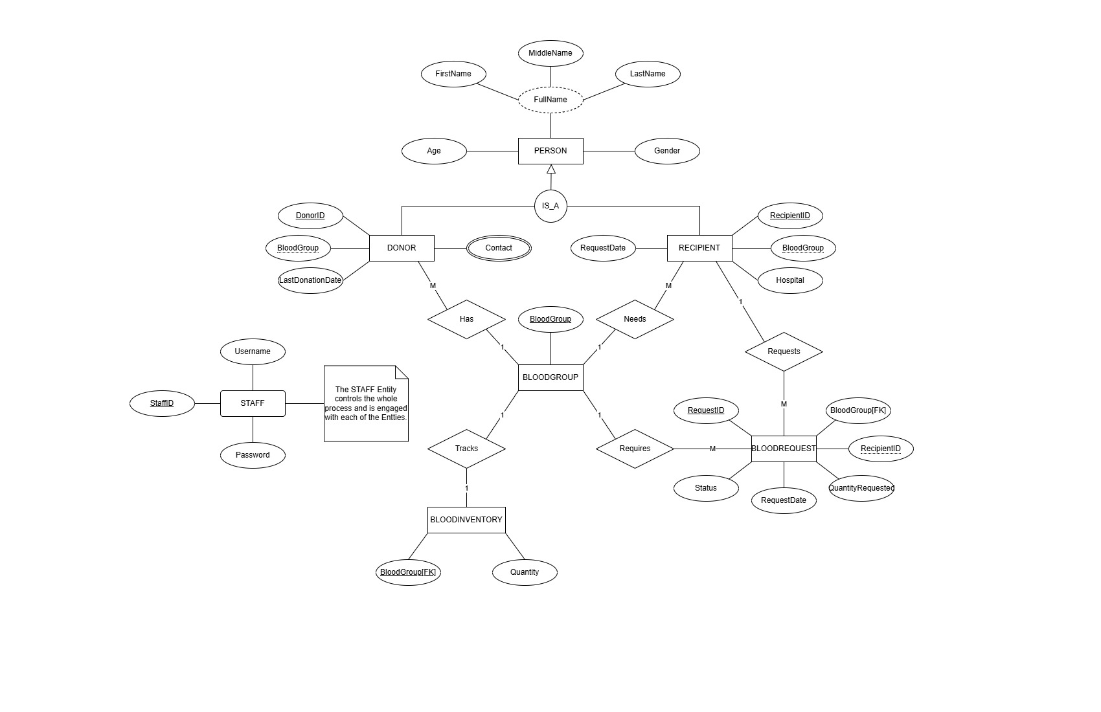
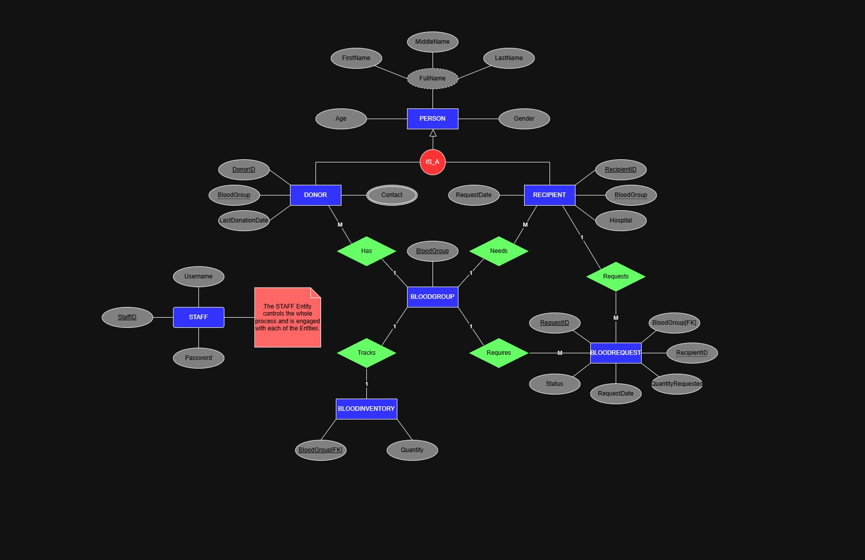

5.3 Database Schema:
- Staff: PK = StaffID
- Donor: PK = DonorID
- Recipient: PK = RecipientID
- BloodInventory: PK = BloodGroup
- BloodRequest: PK = RequestID, FK = RecipientID

5.4 Relational Database Diagram Screenshots:
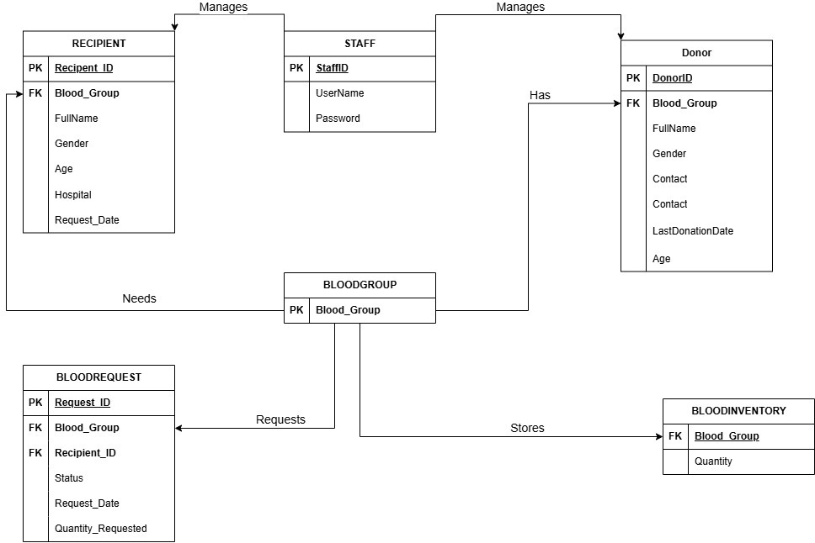

5.5 Normalization Process:
- 1NF: Ensured atomic attributes
- 2NF: Removed partial dependencies (each table has a unique PK)
- 3NF: Removed transitive dependencies (separate Recipient and BloodRequest tables)

Implementation Overview:
- Swing GUI used for forms and dashboards.
- JTable for displaying data (donors, inventory).
- Event Listeners for handling buttons and forms.
- DAO (Data Access Object) Pattern for database access abstraction.

Database Implementation

7.1 DBMS Selection:
MySQL was chosen by us for its open-source nature, ease of use, and compatibility with Java JDBC.

7.2 Table Creation Scripts:
-- Blood Groups Reference Table (Optional, for normalization)
CREATE TABLE BloodGroup (
BloodGroup NVARCHAR(5) PRIMARY KEY
);

-- Donors Table
CREATE TABLE Donor (
DonorID INT PRIMARY KEY IDENTITY(1,1),
FullName NVARCHAR(100) NOT NULL,
Age INT NOT NULL CHECK (Age >= 18 AND Age <= 65),
Gender NVARCHAR(10) NOT NULL CHECK (Gender IN ('Male', 'Female', 'Other')),
BloodGroup NVARCHAR(5) NOT NULL FOREIGN KEY REFERENCES BloodGroup(BloodGroup),
Contact NVARCHAR(50) NOT NULL
);

-- Blood Inventory
CREATE TABLE BloodInventory (
BloodGroup NVARCHAR(5) PRIMARY KEY FOREIGN KEY REFERENCES BloodGroup(BloodGroup),
Quantity INT NOT NULL CHECK (Quantity >= 0)
);

-- Recipients Table
CREATE TABLE Recipient (
RecipientID INT PRIMARY KEY IDENTITY(1,1),
FullName NVARCHAR(100) NOT NULL,
Age INT NOT NULL CHECK (Age > 0),
Gender NVARCHAR(10) NOT NULL CHECK (Gender IN ('Male', 'Female', 'Other')),
BloodGroup NVARCHAR(5) NOT NULL FOREIGN KEY REFERENCES BloodGroup(BloodGroup),
Hospital NVARCHAR(100) NOT NULL,
RequestDate DATE NOT NULL
);

-- Admin/Staff Table
CREATE TABLE Staff (
StaffID INT PRIMARY KEY IDENTITY(1,1),
Username NVARCHAR(50) NOT NULL UNIQUE,
Password NVARCHAR(100) NOT NULL
);

-- Blood Request Table
CREATE TABLE BloodRequest (
RequestID INT PRIMARY KEY IDENTITY(1,1),
RecipientID INT NOT NULL FOREIGN KEY REFERENCES Recipient(RecipientID),
BloodGroup NVARCHAR(5) NOT NULL FOREIGN KEY REFERENCES BloodGroup(BloodGroup),
QuantityRequested INT NOT NULL CHECK (QuantityRequested > 0),
Status NVARCHAR(20) NOT NULL CHECK (Status IN ('Pending', 'Fulfilled', 'Rejected')),
RequestDate DATE NOT NULL
);

7.3 Constraints and Relationships:
- Foreign Key from Donor.BloodGroup to BloodGroup.BloodGroup
- Foreign Key from Recipient.BloodGroup to BloodGroup.BloodGroup
- Foreign Key from BloodInventory.BloodGroup to BloodGroup.BloodGroup
- Foreign Key from BloodRequest.BloodGroup to BloodGroup.BloodGroup
- Foreign Key from BloodRequest.RecipientID to Recipient.RecipientID

Data Population

8.1 Sample Data Insert Statements:
INSERT INTO Staff (Username, Password) VALUES
('admin01', 'pass@123'),
('asim.rashid', 'securePass!'),
('fatima.naz', 'bloodbank@2024'),
('kashif88', 'k@sh1fPwd'),
('nimra.staff', 'nimraSecure'),
('hammad.admin', 'h@mm@dPwd'),
('sana.staff', 'sana_2025'),
('ali.tech', 'aliPassword123'),
('sumaira.hr', 'sumi@Hr123'),
('jawad.it', 'j@wad!itpass');

INSERT INTO Recipient (FullName, Age, Gender, BloodGroup, Hospital, RequestDate) VALUES
('Sara Iqbal', 36, 'Female', 'A+', 'Shifa International Hospital, Islamabad', '2025-05-15'),
('Hamza Shahid', 50, 'Male', 'B+', 'Aga Khan University Hospital, Karachi', '2025-05-12'),
('Maria Zubair', 27, 'Female', 'O+', 'Mayo Hospital, Lahore', '2025-05-18'),
('Zeeshan Akhtar', 60, 'Male', 'AB+', 'Punjab Institute of Cardiology, Lahore', '2025-05-10'),
('Areeba Khan', 22, 'Female', 'O-', 'PIMS Hospital, Islamabad', '2025-05-17'),
('Rashid Mehmood', 45, 'Male', 'B-', 'Civil Hospital, Karachi', '2025-05-14'),
('Hira Rauf', 33, 'Female', 'A-', 'Liaquat National Hospital, Karachi', '2025-05-19'),
('Kashif Ali', 38, 'Male', 'AB-', 'Services Hospital, Lahore', '2025-05-16'),
('Asma Farooq', 41, 'Female', 'A+', 'Jinnah Hospital, Lahore', '2025-05-11'),
('Adnan Siddiqui', 55, 'Male', 'B+', 'Combined Military Hospital, Rawalpindi', '2025-05-13');

INSERT INTO Donor (FullName, Age, Gender, BloodGroup, Contact) VALUES
('Ali Raza', 28, 'Male', 'A+', '03001234567'),
('Fatima Noor', 32, 'Female', 'B+', '03111234567'),
('Ahmed Khan', 45, 'Male', 'O+', '03211234567'),
('Sana Tariq', 22, 'Female', 'A-', '03331234567'),
('Zain Ali', 35, 'Male', 'B-', '03441234567'),
('Mehwish Javed', 29, 'Female', 'AB+', '03551234567'),
('Usman Ghani', 40, 'Male', 'O-', '03661234567'),
('Hina Qureshi', 26, 'Female', 'AB-', '03771234567'),
('Bilal Saeed', 31, 'Male', 'A+', '03881234567',),
('Nida Salman', 24, 'Female', 'B+', '03991234567');

INSERT INTO BloodGroup (BloodGroup) VALUES
('A+'), ('A-'), ('B+'), ('B-'),
('AB+'), ('AB-'), ('O+'), ('O-');

8.2 Explanation:
Test data to verify GUI modules like Donor, Recipient, BloodGroup etc and database integration. This seed data will help us in operating our database and our frontend easy for trial and error.

SQL Query Implementation

9.1 CRUD Operations:
- Insert, update, and delete statements in Donor/Recipient/BloodInventory modules.
- Authentication queries for admin login.

9.2 Complex Queries:

SELECT R.RequestID, C.FullName, R.BloodGroup, R.QuantityRequested, R.Status, R.RequestDate FROM BloodRequest R JOIN Recipient C ON R.RecipientID = C.RecipientID;

- Join used to display request records with recipient details.

User Interface Development

10.1 Front-End Design Overview:
- Developed using Java Swing
- Custom gradients, styled components, hover effects
- Separate forms for login, registration, dashboard, and CRUD modules

10.2 Screenshots:

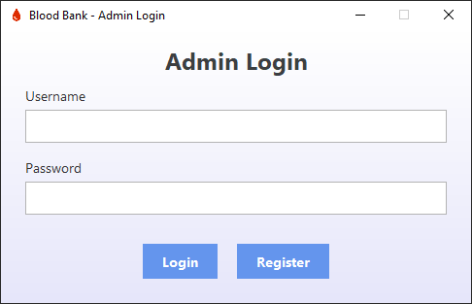
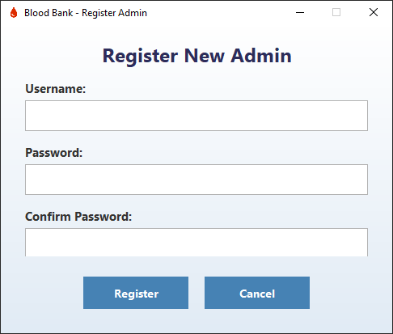
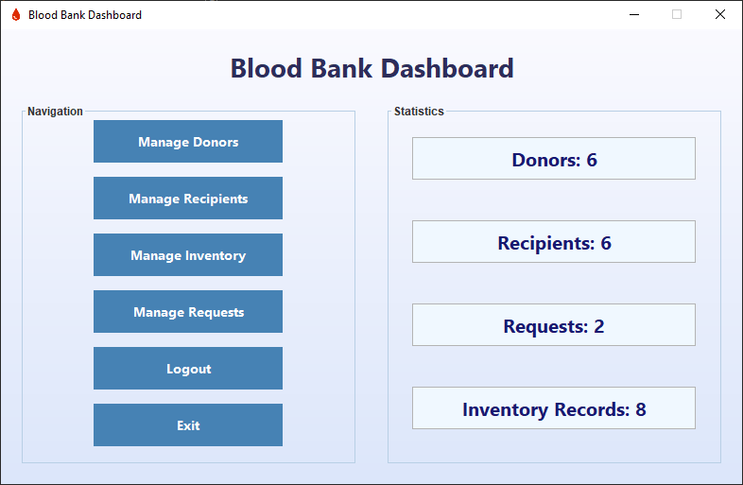
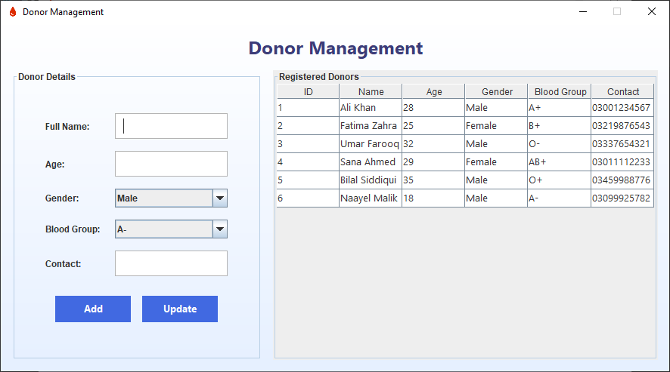
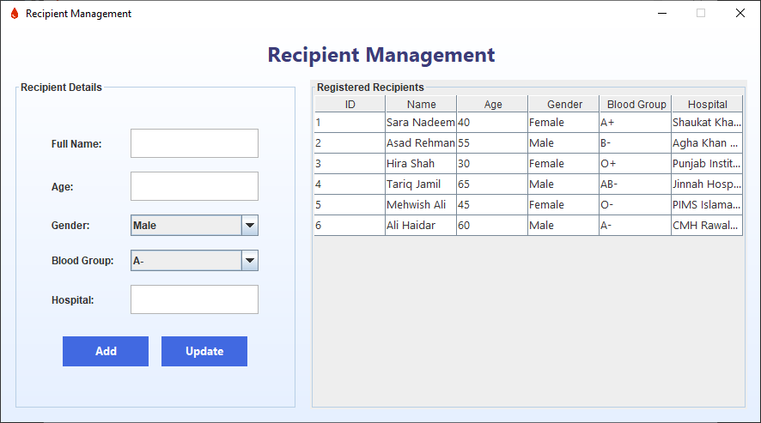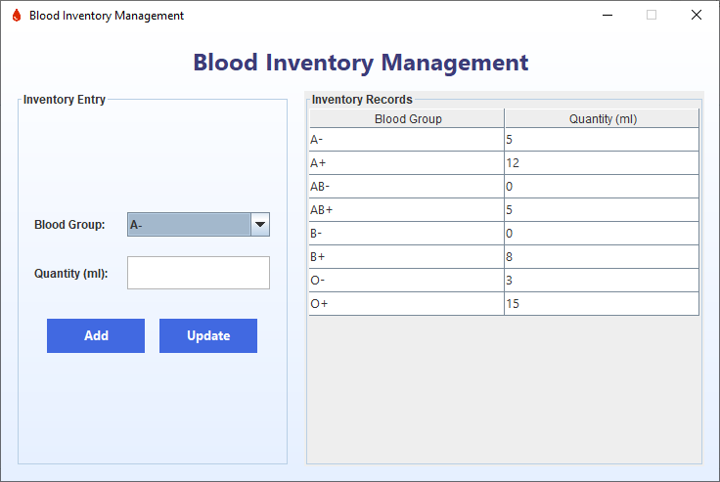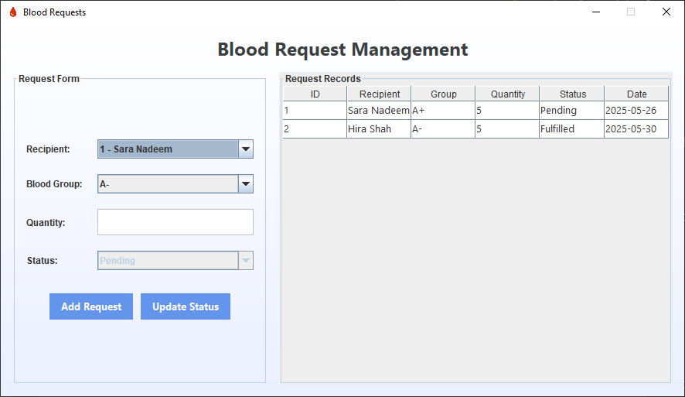

10.3 UI Components:
- JFrame
- JPanel
- JLabel
- JTextField
- JPasswordField
- JButton
- JTable
- JComboBox
- Navigation buttons and stats labels in Dashboard

System Testing and Validation

11.1 Testing Strategy:
- Manual testing for each module
- Boundary value analysis for age, quantity, contact number
- Validation of empty fields and data formats

11.2 Performance Testing:
- Verified responsiveness with datasets of 15+ records
- Acceptable UI performance with real-time updates

Testing
- Unit Testing: Logic for blood availability, donor age validation.
- GUI Testing: Manual validation of form behavior and buttons.
- Database Testing: Query correctness and data integrity.

Challenges Faced
- Data consistency between blood donations and stock management.
- Implementing real-time updates to blood inventory.
- Designing a clean, user-friendly GUI using Java Swing.

Outcomes
- Smooth and accurate management of blood records.
- Fast response to emergency blood requests.
- Reduced human error and paperwork.

Appendix

15.1 Java Swing GUI Code:
Code New.txt

